Change list
文件版本 | 變更說明 | 編修 | 日期
v0.1 | 初版發行 | 吳承翰 | 2019/02/22
v0.2 | 加入圖表說明 | 李涵 | 2019/02/27
v0.3 | 文字編修 | tbjk | 2019/2/28

Xenon TCP接收流程
- 接收起始封包(initial packet) (default port: 60)
- TCP socket接收到起始封包，確認是否符合格式 (見神農起始封包格式)，並因應連線Config啟動對應模式。
- 如啟動確認模式(acknowledge mode) (預設，見Config TCPCK)，伺服器回傳確認封包(ack packet)，等待資料封包(data packet)。
3.1收到資料封包後，如啟動 data packet header (預設，見Config DPH)，則依 data packet header 格式解封包，並確認封包編號 (packet number) 是否正確。如正確，回應確認封包並進行資料解碼。如錯誤，則不回應。
- 如無啟動確認模式也無啟動 data packet header，則直接等待資料封包，並進行資料解碼。
- 回到步驟 3 or 4，直到 TCP socket 連線中斷。

acknowledge mode (TCPACK) on
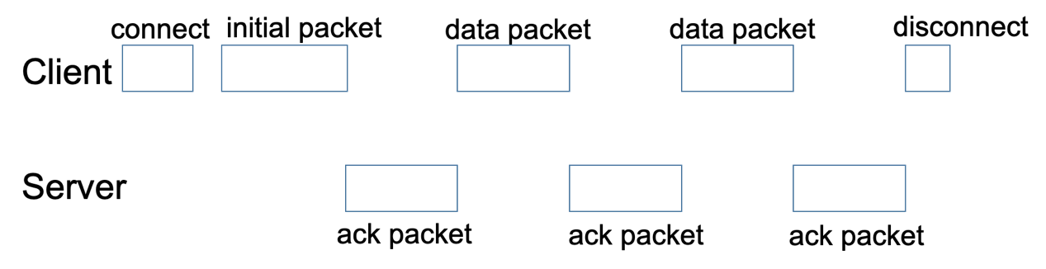

acknowledge mode (TCPACK) off
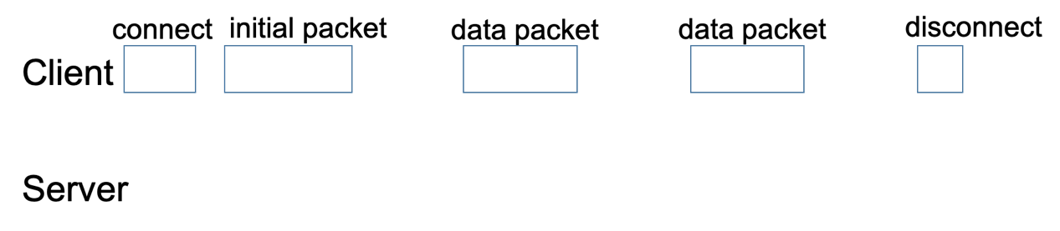
神農起始封包(initial packet)格式
Index | Value | Description
0 | ‘S’ | Header ‘SUCC’
1 | ‘U’ | Header ‘SUCC’
2 | ‘C’ | Header ‘SUCC’
3 | ‘C’ | Header ‘SUCC’
4 | Connection Header Length High Byte  (CHLh) | Connection header= CHLh*256+CHLl without ‘SUCC’
5 | Connection Header Length Low Byte  (CHLl) | Connection header= CHLh*256+CHLl without ‘SUCC’
6 | Uploader Version | Uploader version show in Ascii code (example: ‘P4.0’)
7 | Uploader Version | Uploader version show in Ascii code (example: ‘P4.0’)
8 | Uploader Version | Uploader version show in Ascii code (example: ‘P4.0’)
9 | Uploader Version | Uploader version show in Ascii code (example: ‘P4.0’)
10 | Xenon Dongle Version Byte 1 | Xenon information acquire from dongle, dongle version show in Ascii code (example: ‘8.37’)
11 | Xenon Dongle Version Byte 2
12 | Xenon Dongle Version Byte 3
13 | Xenon Dongle Version Byte 4
14 | Upload Device MAC Byte 1 | MAC of upload device
15 | Upload Device MAC Byte 2 | MAC of upload device
16 | Upload Device MAC Byte 3 | MAC of upload device
17 | Upload Device MAC Byte 4 | MAC of upload device
18 | Upload Device MAC Byte 5 | MAC of upload device
19 | Upload Device MAC Byte 6 | MAC of upload device
20 | Reserved | Reserved
21 | Reserved | Reserved
22 | Xenon Channel High Byte (XCh) | Acquire data from xenon channel, XC= XCh*256+XCl
23 | Xenon Channel Low Byte (XCl) | Acquire data from xenon channel, XC= XCh*256+XCl
24 | Config | See Config
25 | Board ID Byte 1 | Upload device hardware version show in Ascii code (example: ‘TEST’)
26 | Board ID Byte 2
27 | Board ID Byte 3
28 | Board ID Byte 4
29 | [0xAA] | Ending byte, default 0xAA 0x55
30 | [0x55] | Ending byte, default 0xAA 0x55

Config 格式
Bit 7 | Bit 6 | Bit 5 | Bit 4 | Bit 3 | Bit 2 | Bit 1 | Bit 0
DPH | - | - | RFDBH | - | TCPACK | - | -
Bit 7: DPH: data packet header
0: data packet header off
1: data packet header on; see data packet
Bits 6-5: Reserved
Bit 4: RFDBH: RFDB header
0: Data without RFDB header and checksum
1: Data with 4 bytes RFDB header (0x4BF352EC) and 1 byte checksum; see Xenon RFDB Guide
Bit 3: Reserved
Bit 2: TCPACK: acknowledge mode
0: acknowledge mode off
1: acknowledge mode on; server would return acknowledge packet back to the upload device; see acknowledge packet
Bits 1-0: Reserved

確認封包(acknowledge packet, ack packet)格式
Index | Value | Description
0 | ‘R’ | Header ‘RECV’
1 | ‘E’ | Header ‘RECV’
2 | ‘C’ | Header ‘RECV’
3 | ‘V’ | Header ‘RECV’
4 | Received Data Length High Byte  (RDLh) | Data Length= RDLh*256+RDLl without ‘RECV’
5 | Received Data Length Low Byte  (RDLl) | Data Length= RDLh*256+RDLl without ‘RECV’

資料封包(data packet)格式 (DPH on)
Index | Value | Description
0 | ‘X’ | Header ‘XN00’
1 | ‘N’ | Header ‘XN00’
2 | ‘0’ | Header ‘XN00’
3 | ‘0’ | Header ‘XN00’
4 | [0x00] | Default command 0x00
5 | [0x10] | Default command 0x10
6 | Board ID Byte 1 | Upload device hardware version show in Ascii code (example: ‘TEST’)
7 | Board ID Byte 2
8 | Board ID Byte 3
9 | Board ID Byte 4
10 | Packet Number High Byte (PNh) | Packet number (0-65535) = PNh*256+PNl, every connection starts from 0
11 | Packet Number Low Byte (PNl)
12 | Data Length High Byte (DLh) | Data length in each packet  DL= DLh*256+DLl
13 | Data Length Low Byte (DLl) | Data length in each packet  DL= DLh*256+DLl
14 | [0xAA] | Ending Byte, Default 0xAA 0x55
15 | [0x55] | Ending Byte, Default 0xAA 0x55
16~N-3 | Data | Upload data
N-2 | Check Sum High Byte (CSh) | Sum of Data, checksum= CSh*256+CSl
N-1 | Check Sum Low Byte (CSl) | Sum of Data, checksum= CSh*256+CSl

資料封包(data packet)格式 (DPH off)
Index | Value | Description
0…N-1 | Data | Upload data

